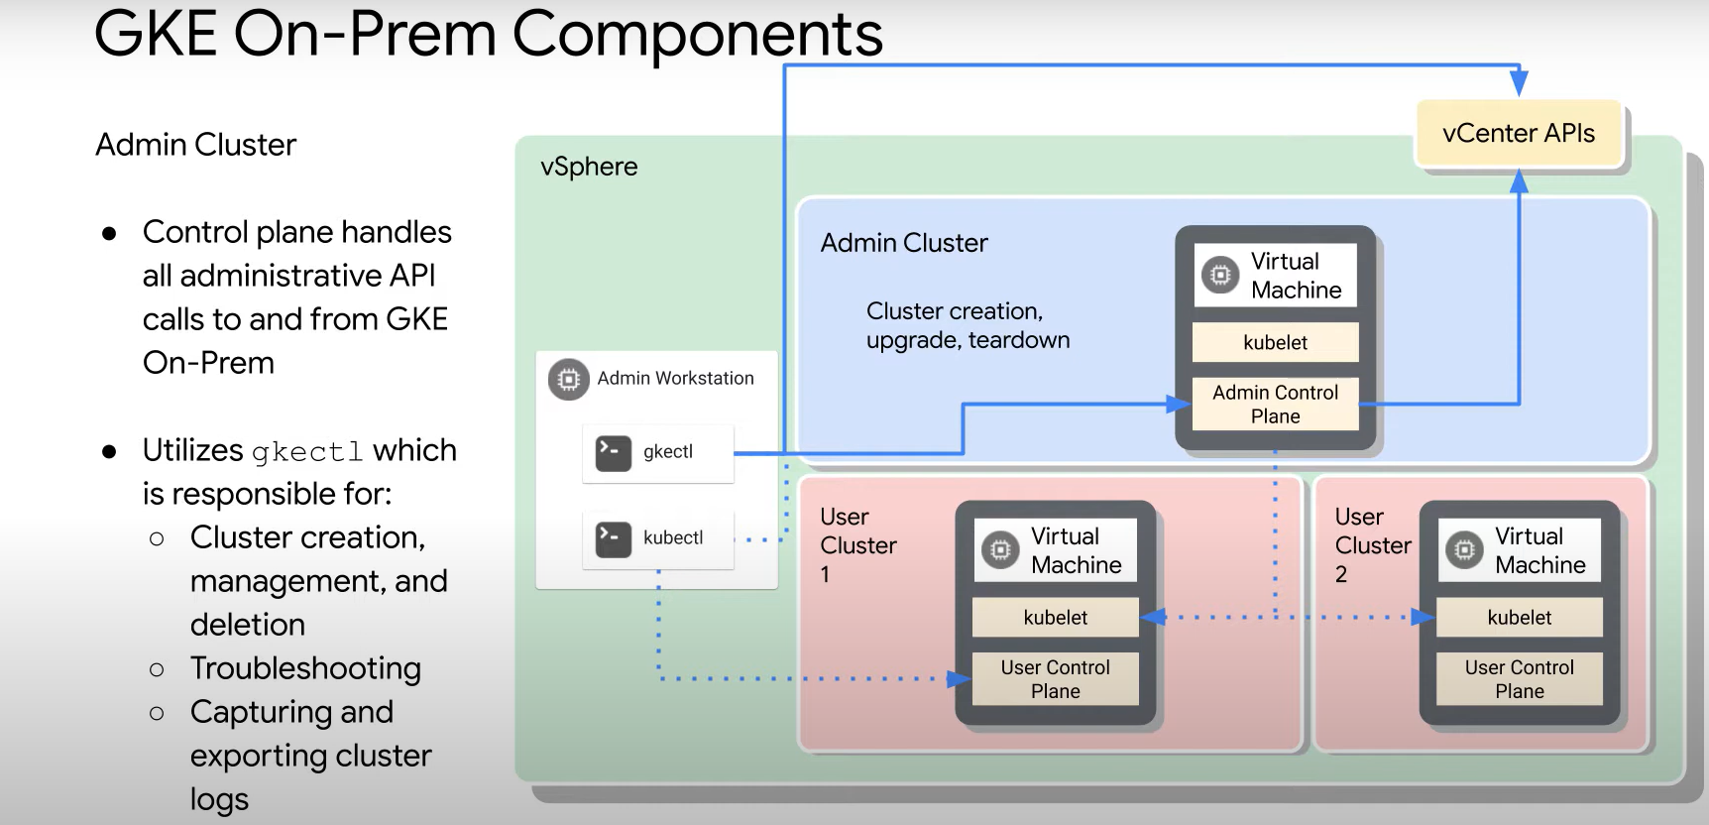

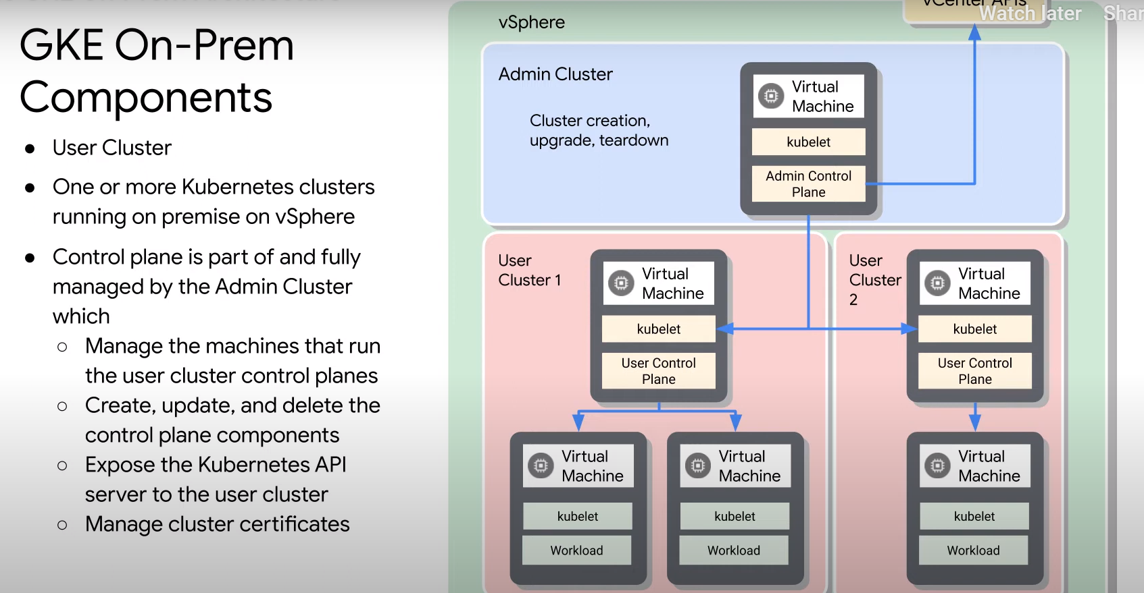

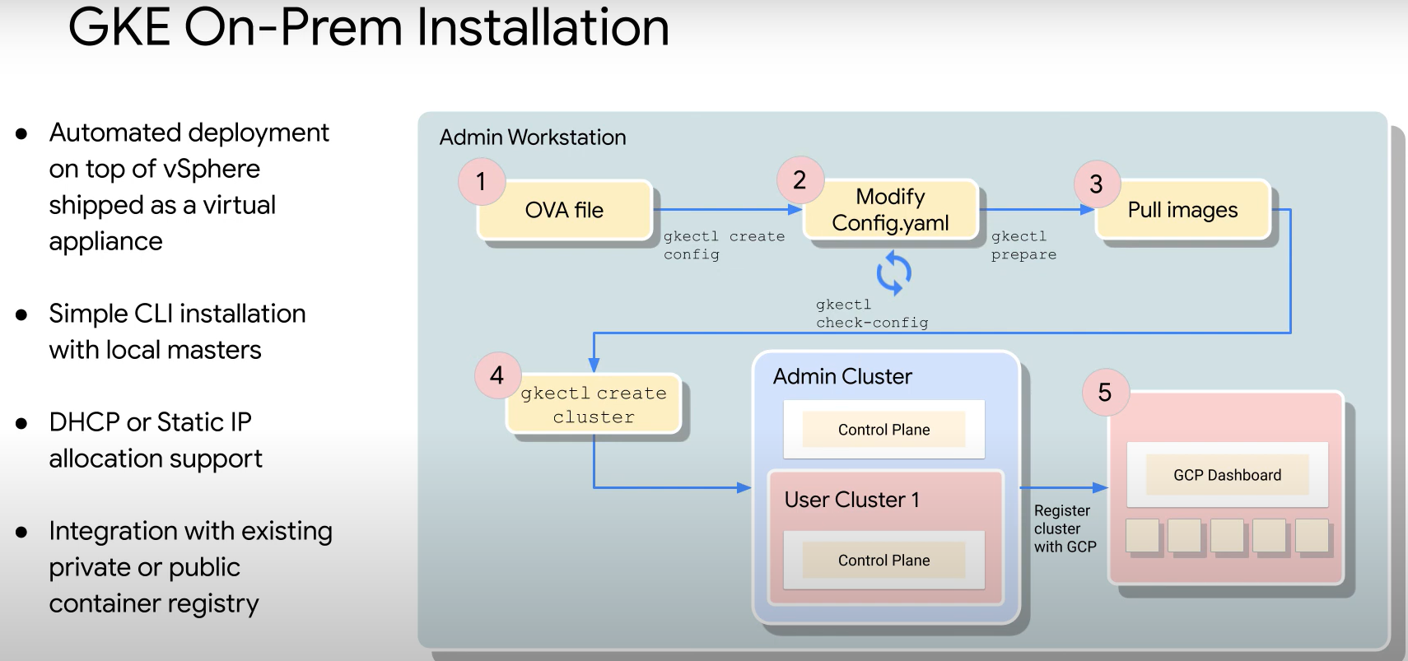

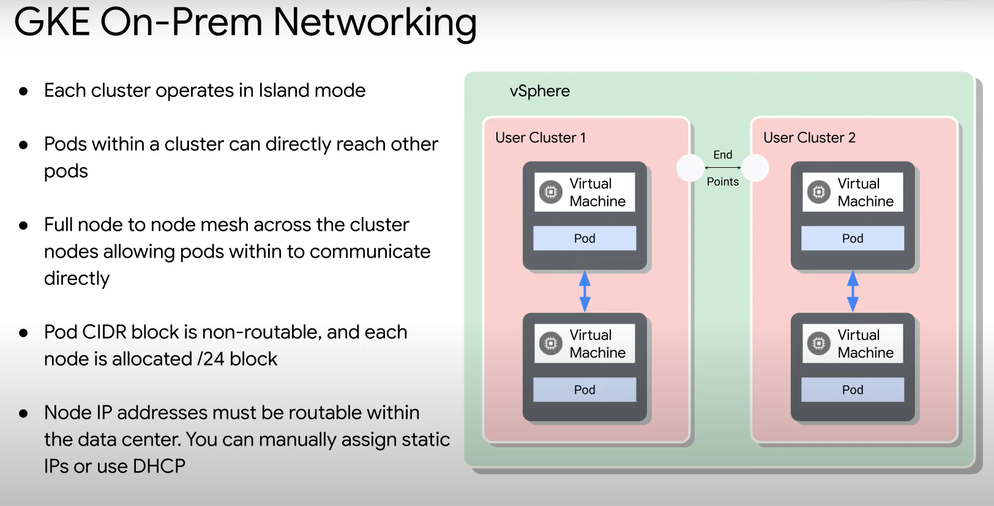

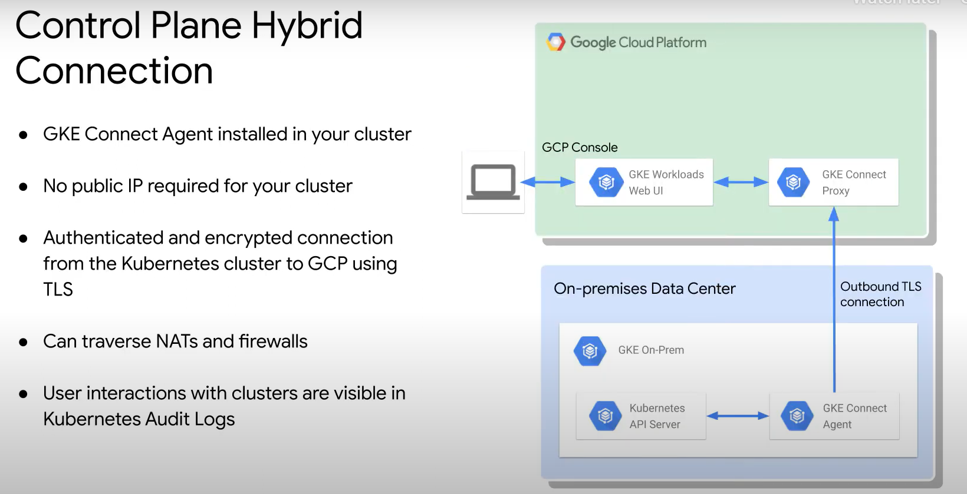

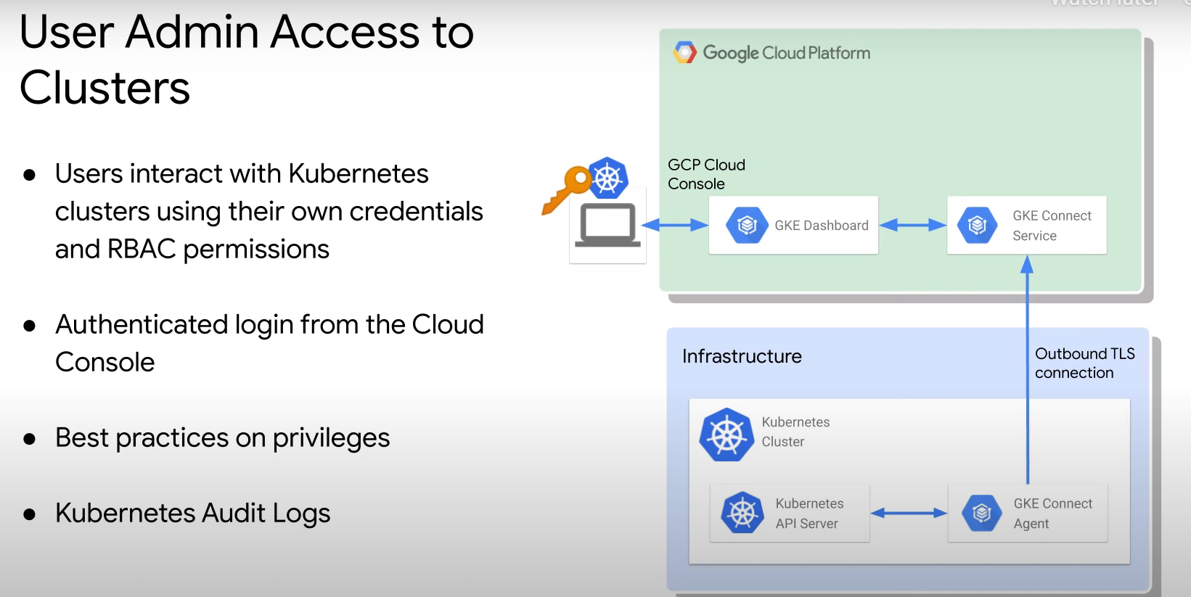

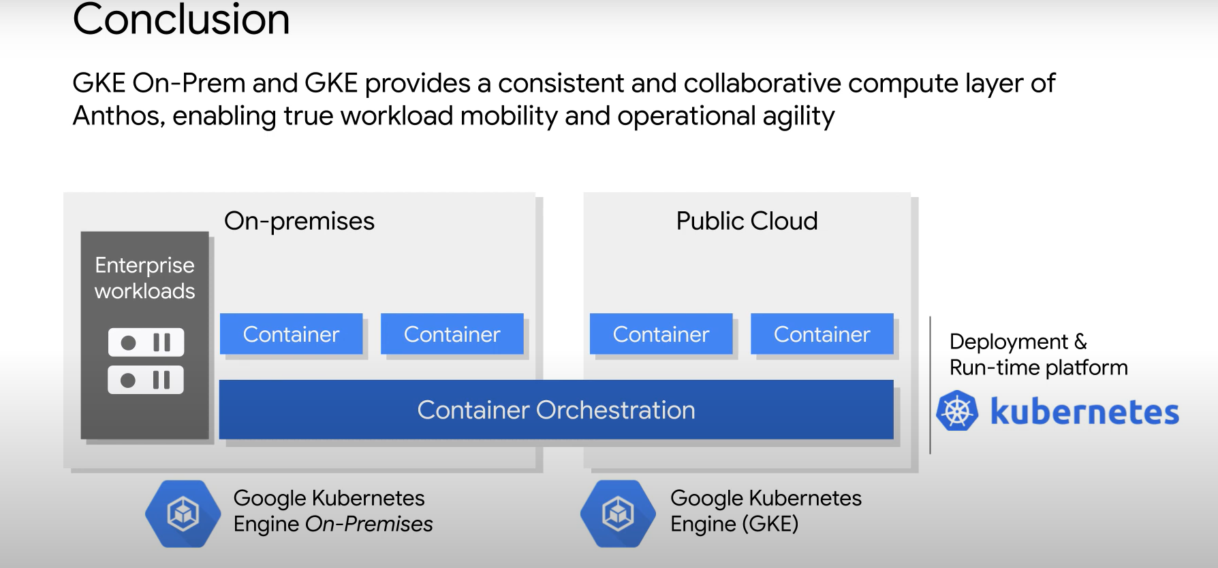

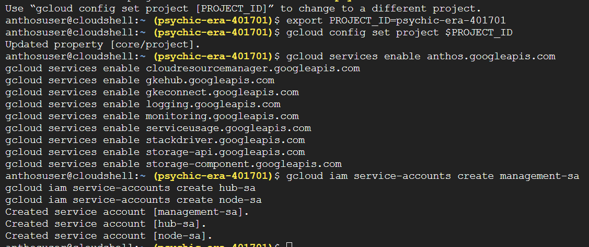

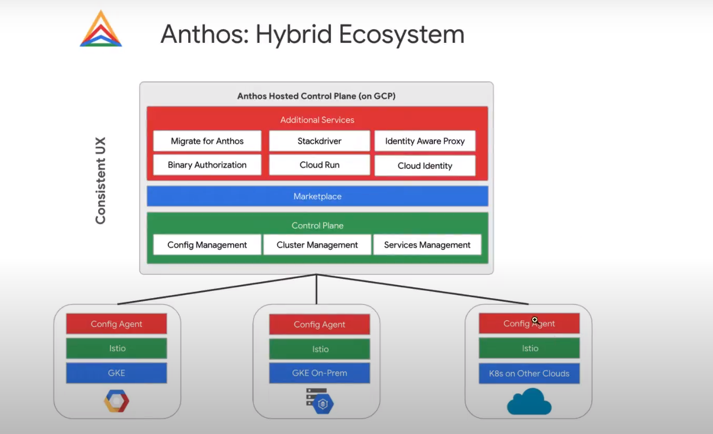

Anthos configuration:

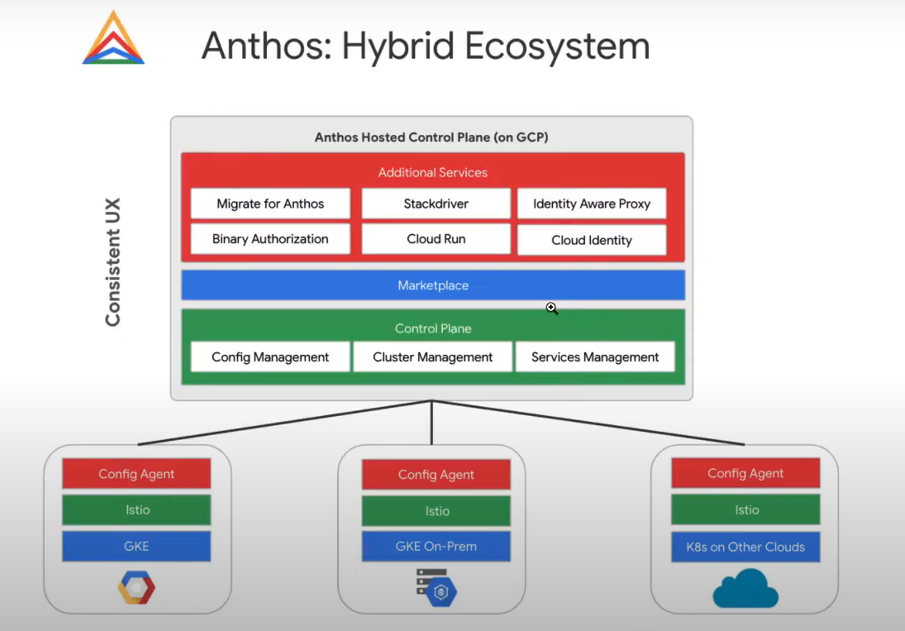

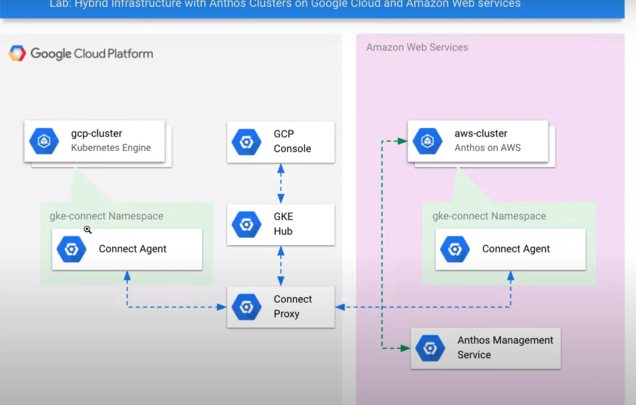





gcloud services enable anthos.googleapis.com  
gcloud services enable cloudresourcemanager.googleapis.com  
gcloud services enable gkehub.googleapis.com  
gcloud services enable gkeconnect.googleapis.com  
gcloud services enable logging.googleapis.com  
gcloud services enable monitoring.googleapis.com  
gcloud services enable serviceusage.googleapis.com  
gcloud services enable stackdriver.googleapis.com  
gcloud services enable storage-api.googleapis.com  
gcloud services enable storage-component.googleapis.com

